Supplementary Materials
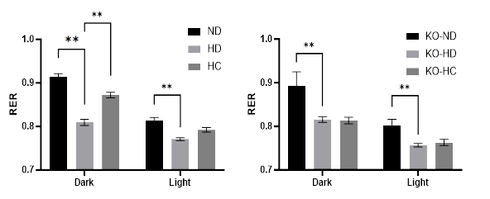

Supplementary Fig. 1. The respiratory exchange ratio (RER) at rest in mice fed with chow (normal diet, ND), high-fat diet (HF), and high-fat plus 0.01% capsaicin diet (HC). The left panel, wild-type mice. The right panel: TRPV1 knock-out (KO) mice. N=4. Data were shown in mean ± SEM. **, p<0.01.
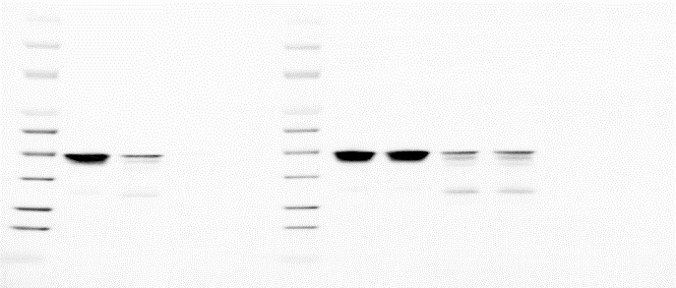
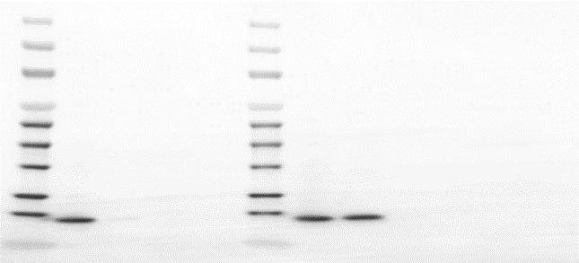
VDAC
β-actin
H3
1 2 3
1 2 3
1 2 3

Supplementary Fig. 2. Representative immunoblotting bands showing the purity of isolated mitochondria from wild-type mouse muscles. Voltage-dependent anion channel (VDAC), Histone H3 (H3), and β-actin serve as marker proteins for mitochondria, nucleus, and cytoskeleton, respectively. Lane 1, whole muscle cells; lane 2, isolated mitochondria; lane 3, blank.

Supplementary Fig. 3. Representative graph showing the functional capacity of the mitochondrial electron transport chain driven by different substrates. Mitochondria were freshly isolated from wild-type mouse skeletal muscle. G, Glutamate; M: Malate; P, Pyruvate; SUC, Succinate.
Supplementary Table 1. The primer sequences used in quantitative reverse transcription-polymerase chain reaction (qRT-PCR).
Gene | Primer | Sequence （5'-3'）
MAP1LC3B | Forward | CCAGGTTGCCTAGCAGAGG
 | Reverse | AACACCAGACCTGCTTAGGG
Tfeb | Forward | CTCTTGCAGAAGACCCCTCT
 | Reverse | AGGGTGGTGGGATAGTGCAA
Sqstm1 | Forward | GAAGCTGCCCTATACCCACA
 | Reverse | TGGGAGAGGGACTCAATCAG
Lamp1 | Forward | CCATTCGCAGTCTCGTAGGTG
 | Reverse | CAGCACTCTTTGAGGTGAAAAAC
β-actin | Forward | ATGGAGCCACCGATCCACA
 | Reverse | CCGTAAAGACCTCTATGCCAAC

List of Abbreviations:
- High-fat diet (HFD)
- Transient receptor potential vanilloid 1 (TRPV1)
- Transcription factor EB (TFEB)
- RNA interference (RNAi)
- Respiratory exchange ratio (RER)
- Knock-out (KO)
- Wild-type (WT)
- Normal diet (ND)
- High-fat plus capsaicin diet (HC)
- High-fat diet (HD)
- Microtubule-associated protein 1 light chain 3B (LC3B)
- Quantitative reverse-transcribed polymerase chain reaction (qRT-PCR)
- Lysosomal-associated membrane protein 1 (LAMP1)
- Sequestosome 1 (Sqstm1)
- Myosin heavy chain (MyHC)
- Perilipin 2 (PLIN2)
- Co-immunoprecipitation (Co-IP)
- Transmission electron microscopy (TEM)
- Bovine serum albumin (BSA)
- Capsazepine (CAPZ)
- Cyclosporine A (CsA)
- Chloroquine (CQ)
- Earle's balanced salt solution (EBSS)
- Cell-associated (CA)
- Dulbecco's modified Eagle's medium (DMEM)
- Fetal bovine serum (FBS)
- Palmitate (PA)
- Capsaicin (CAPS)
- Ethylene glycol-bis(β-aminoethyl ether)-N,N,N′,N′-tetraacetic acid acetoxymethyl ester (EGTA-AM)
- Small interfering RNA (siRNA)
- Radioimmunoprecipitation assay (RIPA)
- Sodium dodecyl sulfate–polyacrylamide gel electrophoresis (SDS–PAGE)
- Standard error of the means (SEM)
- Analysis of variance (ANOVA)

List of compounds：
Compounds | Abbreviation | Catalog Number | Company
Capsaicin | CAPS | M2028 | Sigma-Aldrich
Palmitate | PA | P9767 | Sigma-Aldrich
Capsazepine | CAPZ | C191 | Sigma-Aldrich
Cyclosporine A | CsA | SML1018 | Sigma-Aldrich
Chloroquine | CQ | C6628 | Sigma-Aldrich
EGTA-AM | - | 324628 | Sigma-Aldrich
Bovine Serum Albumin | BSA | BAH66 | Equitech-bio inc.

Supplementary materials and methods：

Imaging TFEB cellular localization

C2C12 myotubes were treated with capsaicin alone or in combination with capsazepine or CsA for 4 hours. Cells were PBS-rinsed, fixed in 4% PFA (20 min), permeabilized with 0.1% Triton X-100 (10 min), and blocked with 5% BSA (30 min), all at room temperature. Subsequently, they were incubated with a primary anti-TFEB antibody (1:200; PA5-96632; Thermo Fisher Scientific, MA, USA) for 1 h at 37°C, followed by a FITC-conjugated secondary antibody (1:1000; 65-6111; Thermo Fisher Scientific, MA, USA) for 30 min after PBS washes. After washing, cells were imaged by fluorescence microscopy (TE2000, Nikon, Tokyo, Japan).

Fluorescence co-staining for LDs and LAMP1 in C2C12 cells and muscle fibers

C2C12 myotubes were treated with palmitate with or without capsaicin for 20 hours, followed by EBSS starvation for 4 hours. After washing twice with PBS, cells were used for Fluorescence co-staining. Cells or frozen-sectioned gastrocnemius muscles were fixed with 4% paraformaldehyde for 20 minutes and blocked with 5% BSA for 30 minutes at room temperature. Then, cells or tissues were incubated for 1 hour with the antibody against LAMP1 (1:200; ab208943; Abcam, MA, USA) at 37℃. After washing, they were incubated with FITC-conjugated secondary antibody (1:1000; 65-6111; Thermo Fisher Scientific, MA, USA) and 10 ug/mL Nile red (IN0170; Solarbio Life Sciences, Beijing, China) for 30 min. After washing, they were imaged by fluorescence microscopy (TE2000, Nikon, Tokyo, Japan).

Dual-luciferase reporter assay

To measure the transcriptional activity of TFEB, C2C12 cells in 48-well plates were transfected with the 4X-CLEAR promoter-reporter construct, using Lipofectamine 2000 Transfection Reagent (Invitrogen). The 4XCLEAR-luciferase reporter was a gift from Albert La Spada (# 66800, Addgene plasmid, MA, USA) (Cortes et al., 2014). To normalize the transfection efficiency, the renilla luciferase reporter vector, pRL-TK (D2760; Beyotime, Shanghai, China), was co-transfected as an internal control. The culture medium was replaced 6 hours post-transfection. At 24 hours, cells were treated with capsaicin alone or combined with capsazepine or CsA for 4 hours, after which luciferase activity was assessed using a Dual-Luciferase Reporter Assay Kit (#RG027, Beyotime, Shanghai, China) per the manufacturer's protocol.

Calcineurin activity assay

C2C12 myotubes were treated with capsaicin alone or in combination with capsazepine, cyclosporine A, or EGTA for 4 hours. Cells were lysed in 200 μL of ice-cold buffer (50 mM Tris-HCl, 0.1 mM EDTA, 0.1 mM EGTA, 0.2% NP-40, 1 mM DTT, plus protease inhibitors), and the supernatant was collected by centrifugation (13,000 rpm, 10 min, 4°C). Following protein concentration determination via a BCA kit, calcineurin phosphatase activity was assessed using a commercial assay kit according to the manufacturer's instructions.

TFEB siRNA knockdown

To down-regulate TFEB, a unique 27mer siRNA duplex against mouse TFEB(SR416907A, OriGene, Rockville, MD, USA) was introduced to C2C12 cells in parallel to scrambled siRNA (SR30004, OriGene, Rockville, MD, USA) by using Lipofectamine 2000 (Invitrogen) according to the manufacturer's instructions. After 48 hours of transfection, the efficiency of siRNA-mediated silencing of TFEB was checked by immunoblotting. The TFEB siRNA sequence is: 5’-GGAGAUGACUAACAAAGCAGC CUC-3’. The scrambled negative control siRNA sequence is: 5’-CGUUAAUCGCGUAUAAUACGCG UAU-3’.

Western blot

Mouse gastrocnemius muscles or cultured cells were lysed in RIPA buffer (1% Triton‐X, 0.1% SDS, 0.5% deoxycholate, 50 mmol/L Tris pH7.5, 150 mmol/L NaCl, protease inhibitor). Equal amounts of protein (50 μg per lane) were denatured, resolved on sodium dodecyl sulfate-polyacrylamide gels (SDS–PAGE), and then transferred to polyvinylidene difluoride membranes (Millipore). After blocking, the membranes were incubated with the primary antibodies (diluted by 1:1000) at 4℃ overnight. The primary antibody against TFEB (PA5-96632) was purchased from Thermo Fisher Scientific. Primary antibodies against β-actin (A1978) and LC3B (L7543) were purchased from Sigma-Aldrich. Primary antibodies against LAMP1 (ab208943), p62 (ab109012), PLIN2 (ab108323), histone H3 (ab1791) and VDAC (ab14734)were purchased from Abcam (MA, USA). Following incubation with the specy-matched secondary antibody (diluted by 1:2000), Goat Anti-Rabbit IgG H&L (HRP) (ab6721, Abcam) or Goat Anti-Mouse IgG H&L (HRP) (ab6789, Abcam), at 37°C for 1 h, immunoreactive bands were visualized by enhanced chemiluminescence and quantified densitometrically using Quantity One software (Bio-Rad, CA, USA), with values normalized to β-actin.

Co-immunoprecipitation (Co-IP)
Co-IP was performed by using the Cellular Labeling and Immunoprecipitation Kit (Roche Diagnostics, Basel, Switzerland). Mouse gastrocnemius muscles were lysed in the lysis buffer. Lysates were precleared with 20 μL of Dynabeads Protein A (Cat.no.10001D, Thermo Fisher Scientific, MA, USA) for 20 min 4 °C, then immunoprecipitated with 1 μg of anti-PLIN2 (ab108323, Abcam, MA, USA) or the same amount of control IgG antibody (ab37415, Abcam, MA, USA) and 20 μL of Dynabeads Protein A for 4 h at 4 °C with gentle rotation. After six washes with lysis buffer, bound complexes were eluted in 1× Laemmli buffer at 65°C for 25 min to ensure solubility. Then, the bound complexes were analyzed by western blotting for p62 (1:1000; ab109012, Abcam, MA, USA) and PLIN2 (ab108323, Abcam, MA, USA). The raw input and IgG were loaded as control. The secondary antibody was Goat Anti-Rabbit IgG H&L (HRP) (1:2000; ab6721, Abcam, MA, USA). The Western blot was performed according to the method described above.

